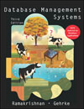 COSC 3380
Name: _Thanh Vo_______ Seat# _D9_
Updated 11/2/2016
Project 3:
(100 points.)
(Due date found in the COSC 3380 Detailed Syllabus!)

Use the COSC3380 Database created in Project 2.

Part 1. Stored Procedures

1.
a. Create a simple procedure ProductLineSale, to be used by that will set a sale price to the existing Product table in the COSC3380 Database by adding a new column, SalePrice DECIMAL (6,2), that will hold the sale price for the products:

.

The ProductLineSale procedure should scan all rows of the Product table. Products with a ProductStandardPrice of $400 or higher are discounted 10 percent, and products with a ProductStandardPrice of less than $ 400 are discounted 15 percent. As with other database objects, there are Oracle SQL commands to create, alter, replace, drop, and show the code for procedures.

b. Run the ProductLineSale procedure in Oracle.

c. Display the contents of the PRODUCT table.

/*Part 1. Stored Procedures*/
/*Create new column SalePrice in table Product*/
ALTER TABLE Product DROP COLUMN SalePrice;
ALTER TABLE Product ADD SalePrice DECIMAL(6,2);

/*1.a) Create the procedure*/
CREATE OR REPLACE PROCEDURE ProductLineSale
IS
/*declare the variables that store the sale price, the standard price and the product id*/
Sale Product.SalePrice%type;
Price Product.ProductStandardPrice%type;
PID Product.ProductID%type;

/*use cursor to select all product id and standard price from product table*/
CURSOR get_price IS
SELECT ProductID, ProductStandardPrice FROM Product;

BEGIN

/*open the cursor */
OPEN get_price;
LOOP
/*store product id and price at a row into variables and exit loop if no more data retrieved*/
FETCH get_price INTO PID, Price;
EXIT WHEN get_price%NOTFOUND;

/*if the price >= 400, the sale price is 90% of price; otherwise, 85% of the price*/
IF Price >= 400 THEN
Sale := 0.90 * Price;
ELSE
Sale := 0.85 * Price;
END IF;

/*update the new values to SalePrice column*/
UPDATE Product SET SalePrice = Sale WHERE ProductID = PID;
END LOOP;
COMMIT;
END ProductLineSale;
/
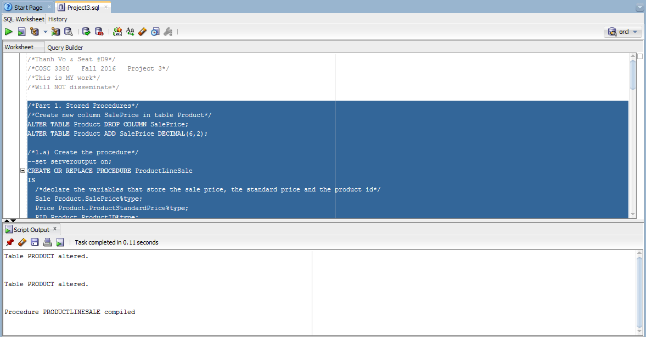

/*1.b) execute the procedure*/
BEGIN
ProductLineSale();
END;
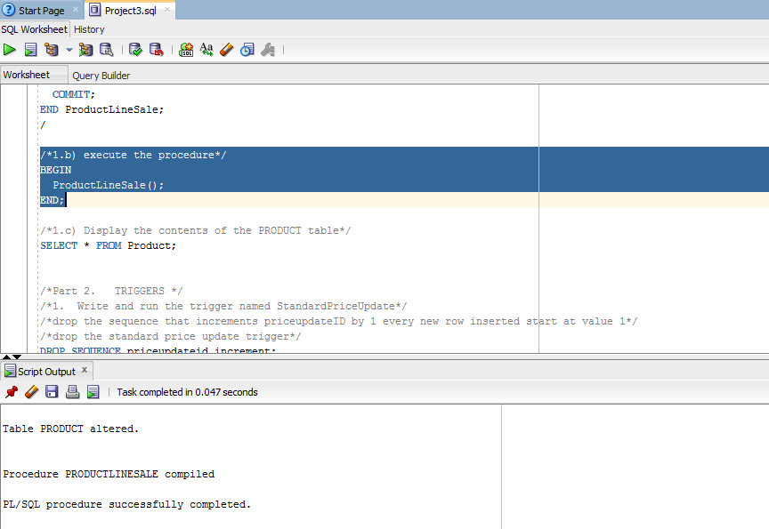

/*1.c) Display the contents of the PRODUCT table*/
SELECT * FROM Product; 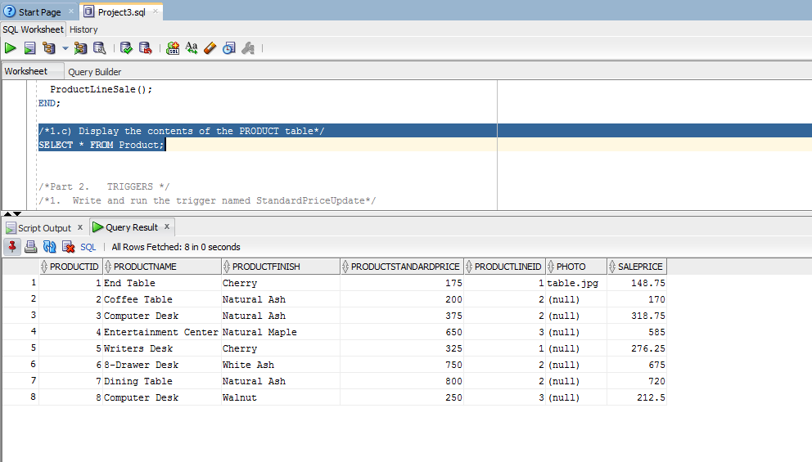

Part 2. TRIGGERS
Consider the following example: The inventory manager needs to know (the action of being informed) when an inventory item’s standard price is updated in the Product table (the event). After creating a new table, PriceUpdates, write a trigger that enters each product when it is updated, the date that the change was made, and the new standard price that was entered.

- Write and run the trigger named StandardPriceUpdate

/*Part 2. TRIGGERS */
/*1. Write and run the trigger named StandardPriceUpdate*/
/*drop the standard price update trigger*/
/*drop the PriceUpdate table*/
DROP TRIGGER StandardPriceUpdate;
DROP TABLE PriceUpdate;

/*Create table PriceUpdate*/
CREATE TABLE PriceUpdate (
UpdateProductID INTEGER,
DateChanged DATE,
OldPrice INTEGER,
NewPrice INTEGER
);

/*create the trigger after the product table is updated*/
CREATE OR REPLACE TRIGGER StandardPriceUpdate
AFTER UPDATE ON Product
FOR EACH ROW
BEGIN
/*insert new data row to PriceUpdate table*/
INSERT INTO PriceUpdate (UPDATEPRODUCTID, DATECHANGED, OLDPRICE, NEWPRICE) VALUES (:OLD.ProductID, SYSDATE, :OLD.ProductStandardPrice, :NEW.ProductStandardPrice);
END;
/
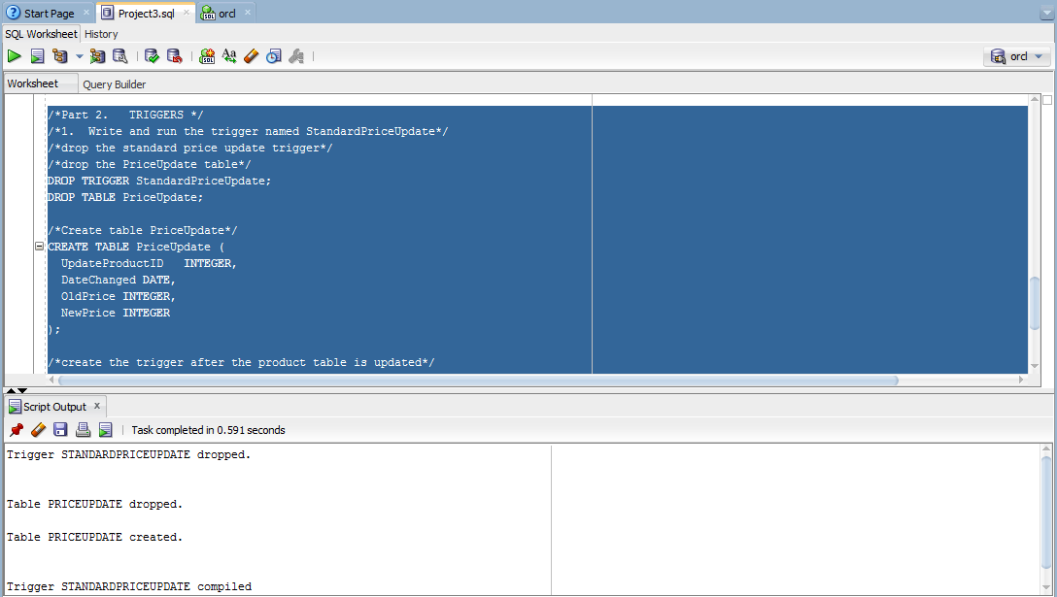

Part 3. Accessing COSC3380 Database from JSP and PHP and ASP:

Create a simple Web Page whose purpose is to display SalestoDate from the database, a report that will be used by the Product Manager (product ID, product description, #number of times the product was ordered.

a. A JSP Web Page
Create SalestoDate.jsp

(jsp page oracle 12c DBMS backend)

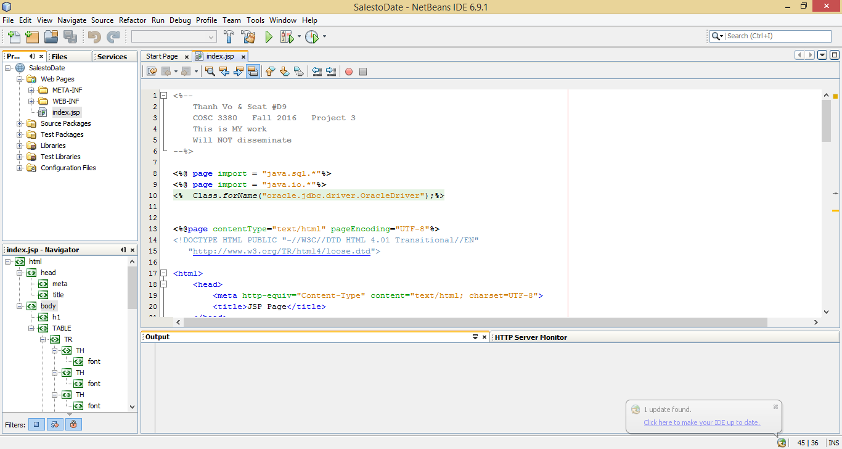
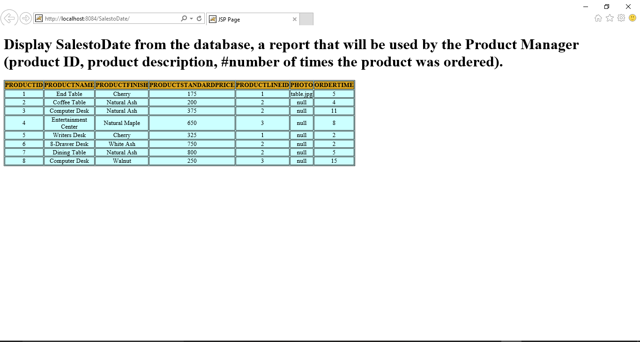

b. A PHP Web Page
Java, C, C++, C#, and Perl are APIs that can be used with MySQL. PHP is one of the most popular APIs for several reasons. Support for MySQL has been built into PHP since PHP4. It has a reputation for ease of use, short development time, and high performance. PHP5, recently released, is more object oriented than PHP4 and includes several class libraries. It is considered to be relatively easy to learn. Intermediate- level programmers will learn it quickly.
Create SalestoDate.php

(php page mysql DBMS backend; Please create and turn in Project3mysql.sql)
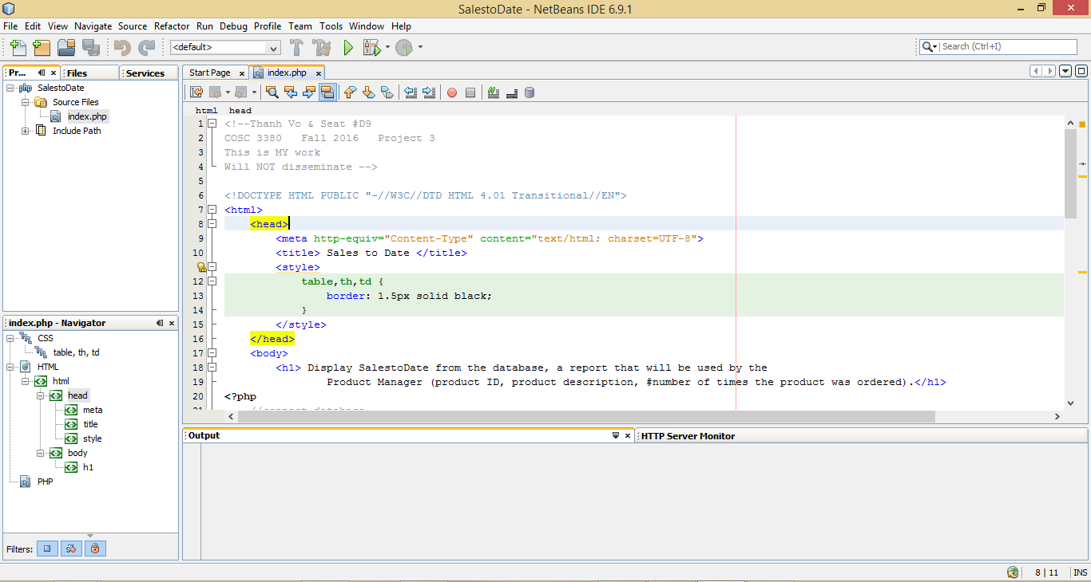
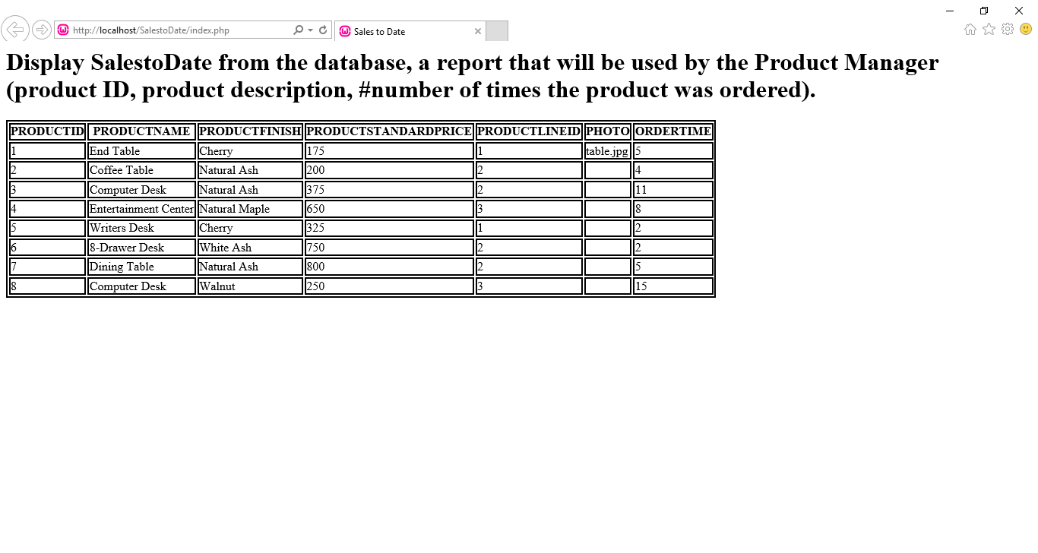

c. An ASP.NET Web Page
Create SalestoDate.aspx

(asp page oracle 12c DBMS backend)
